Practical No 16

VIII. Resources required (Additional)
→ If any web resources required.

Resources used (Additional)
→ https://docs.microsoft.com/en-us/dotnet/visual-basic/language- reference/statements/function-statement
→ https://www.tutorialspoint.com/vb.net/vb.net_functions.htm

Program Code
  - Write a program using Simple Function and Parameterized Function.
- Module Module1 Sub Main()
show()
Dim a, b As Integer Console.WriteLine("Enter Two Numbers") a = Console.ReadLine()
b = Console.ReadLine() Add(a, b)
Console.WriteLine("Addition is = " & Add(a, b)) Console.ReadLine()
End Sub
Public Function show() Console.WriteLine("This is Simple Function")
End Function
Public Function Add(ByVal i As Integer, ByVal j As Integer)
Dim sum As Integer sum = i + j
Return sum End Function End Module

Results (output of the program)
This is Simple Function Enter Two Numbers
45
65
Addition is = 110

Practical related Questions
  - Function returns a value (TRUE / FALSE).
- Function returns a value - True

Error – ‘Tyep Expected’
- Corrected Code
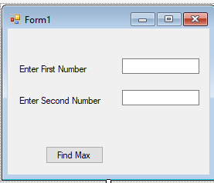Function FindMax(ByVal num1 As Integer, ByVal num2 As Integer) As Integer Dim result As Integer
If (num1 > num2) Then result = num1
Else
result = num2 End If
FindMax = result End Function

rcise
  - Write a program to identify maximum number using parameterized function. (Use two Textbox for input a integer number and display output in Message Box)
➢

Public Class Form1
Private Sub Button1_Click(sender As Object, e As EventArgs) Handles Button1.Click
Dim a, b As Integer Dim res As Integer
a = Val(TextBox1.Text) b = Val(TextBox2.Text) Call findmax(a, b)
res = findmax(a, b) MessageBox.Show("Maximum Number is" & res) Console.ReadLine()
End Sub
Private Function findmax(ByVal num1 As Integer, ByVal num2 As Integer) Dim result As Integer

If (num1 > num2) Then result = num1
Else
result = num2 End If
findmax = result End Function
End Class

OUTPUT:

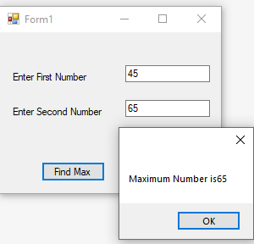
2. Write a program using recursion(Factorial).
- Module Module1
Sub Main()
Dim n As Integer Console.WriteLine("Enter Number=") n = Console.ReadLine() Console.WriteLine("Result=") Console.WriteLine(Fact(n)) Console.ReadLine()
End Sub
Function Fact(ByVal n As Integer)
If n = 0
Fact Else
Fact End If
End Function End Module
OUTPUT:
Enter Number= 5
Result=
120
Then
= 1
= n * Fact(n - 1)

